GRANT AWARD

We are pleased to announce that Missouri Botanical Garden’s Madagascar Research and Conservation Program has received a grant from IUCN Save Our Species for a project titled “Mobilizing local youth to conserve Eulemur cinereiceps at the Ankarabolava-Agnakatrika Forest, Madagascar”. This 2-year project is summarised below.

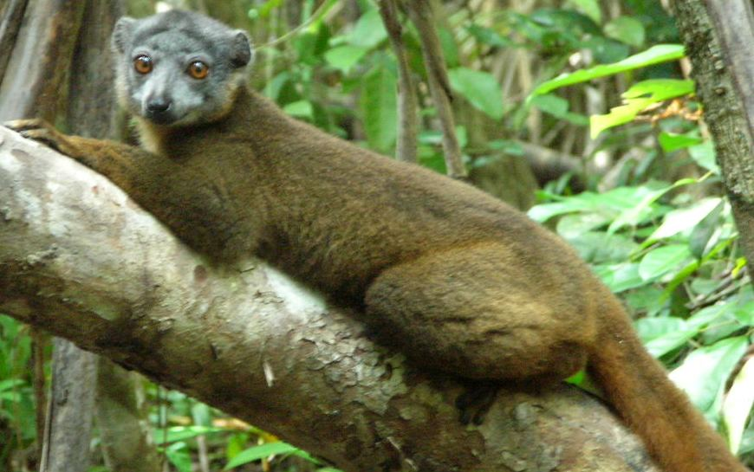
Eulemur cinereiceps photo by Ludovic Reza
The White Collared Lemur, Eulemur cinereiceps, is critically endangered and known from just four protected areas in a small part of SE Madagascar. One of these sites is the 1553-hectare Ankarabolava-Agnakatrika Forest where Missouri Botanical Garden has supported community-based conservation since 2009. This forest is compromised as lemur’ habitat because of the presence within its limits of agricultural plots belonging to 78 farmers. Previously, these farmers, who have traditional occupancy rights, were offered title to equivalent plots of land outside the reserve in exchange for abandoning their land within the forest. To date some 60 farmers have accepted this offer thereby releasing 63 hectares of land. In this project we will propagate 50,000 seedlings of native tree and shrub species including key food plants for E. cinereiceps and then work with local youth to plant these seedlings on 20 hectares of the abandoned land in the forest where natural forest regeneration is slow. The restoration of this land will increase the area of habitat available for E.cinereiceps and improve the integrity of its habitat. The planting events will be valorised to raise awareness of the importance of lemur conservation.

Funded by IUCN Save Our Species

This project is funded by IUCN Save Our Species. The contents of this article are the sole responsibility of Chris Birkinshaw (MBG) and do not necessarily reflect the views of IUCN.

