SELECTION OF IMAGES SHOWING REPAIRED DAM AND IRRIGATION CANALS AT MAHAZOARIVO
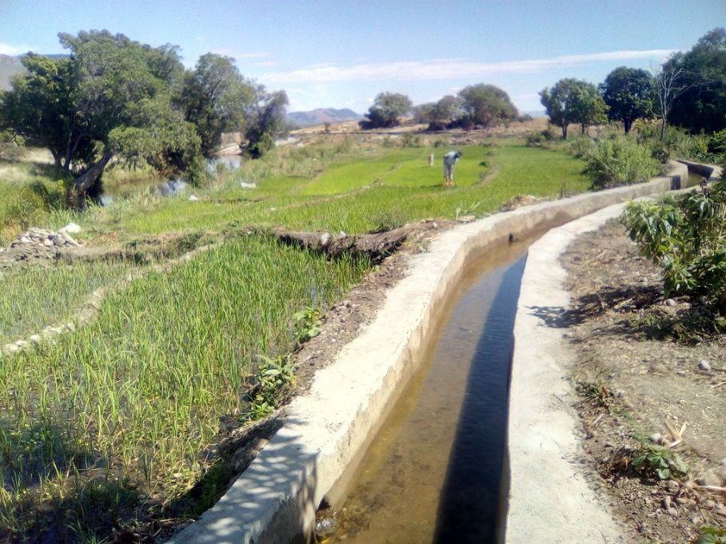 | 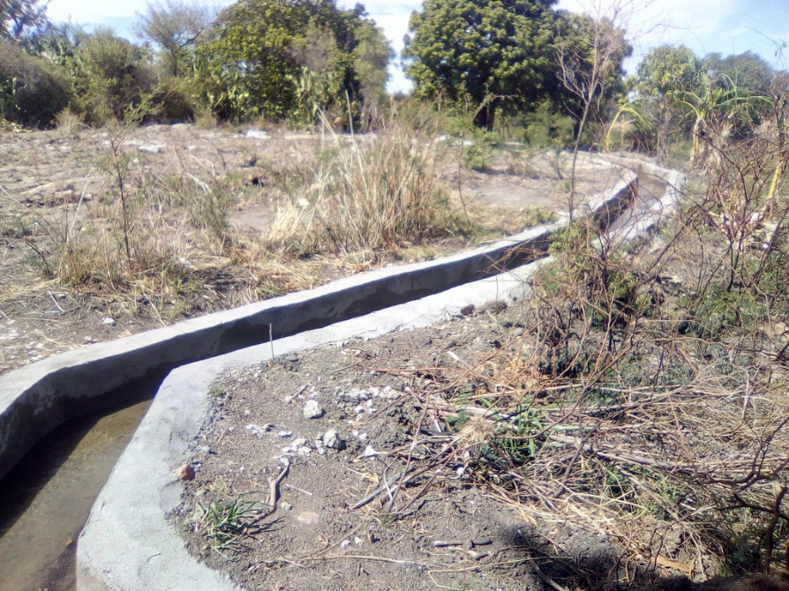
Repaired irrigation canal - over 1 km long!
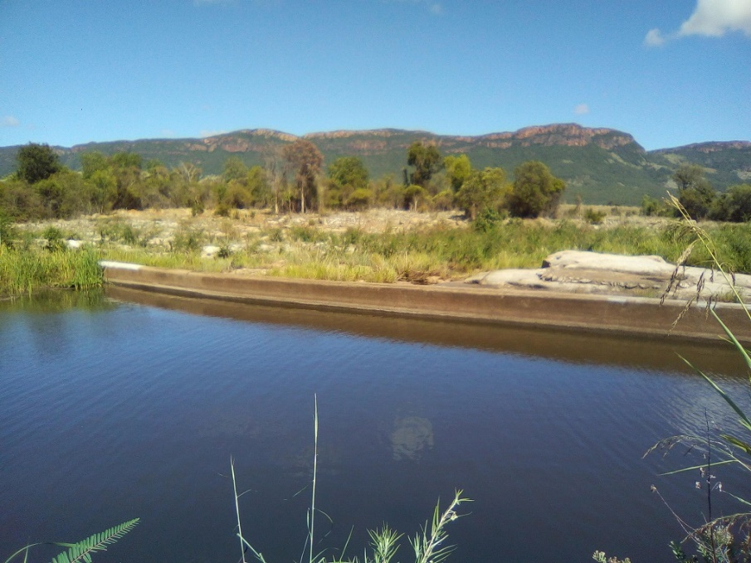 | 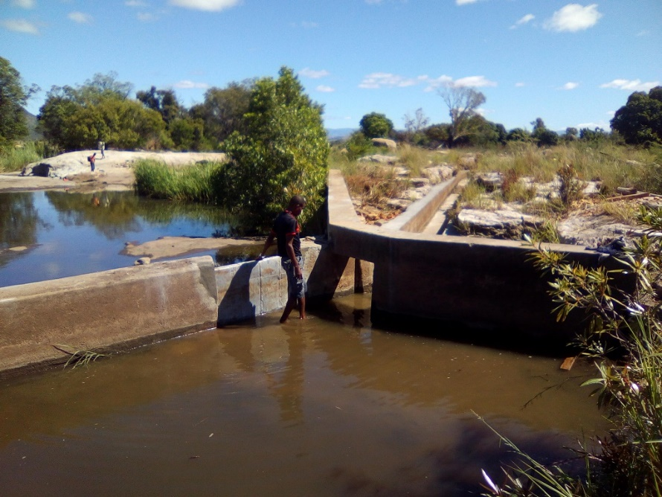
Rehabilitated dam

